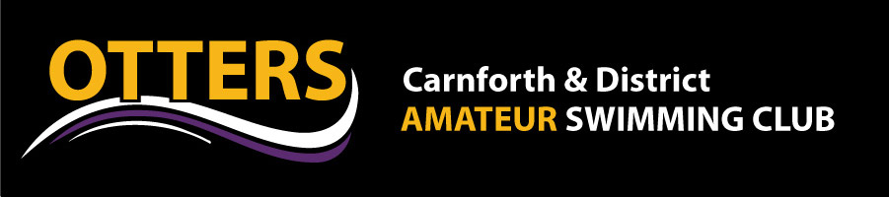
KIT ORDER FORM

Child Club Kit Items | Price |  | Adult Club Kit Items | Price
Cool T-shirt | £13 |  | Cool T-shirt | £14
Polo T-shirt | £14 |  | Polo T-shirt | £15
¾ Leggings | £16 |  | ¾ Leggings | £18
Tracksuit top | £20 |  | Tracksuit top | £25
Tracksuit bottoms | £18 |  | Tracksuit bottoms | £22
Hoodie | £20 |  | Hoodie | £25
Joggers | £15 |  | Joggers | £18
Soft Shell Jacket | £30 |  | Soft Shell Jacket | £35
Onesie | £30 |  | Onesie | £33
Child Sizes Available –  Age 5-6yrs, 7-8yrs, 9-11yrs, 12-13yrs |  |  | Adult Sizes Available –  S, M, L, XL
Carnforth Otters Club Swimming Hats are also available to be ordered

Otters Logo £9.50

Otters Logo and Personalisation £12.50

Please provide the following details via email treasurer@carnforthotters.co.uk

Childs Name, Parent Name and Contact Number/Email

Personalisation details, item, size and quantity ordered.

BACS payment to please be made on placing order with reference Childs Name KIT:

Carnforth and District Otters ASA
Account Number: 80200026
Sort Code: 20 55 41

Unfortunately we are not able to place orders for items unless they have been paid for in full.

