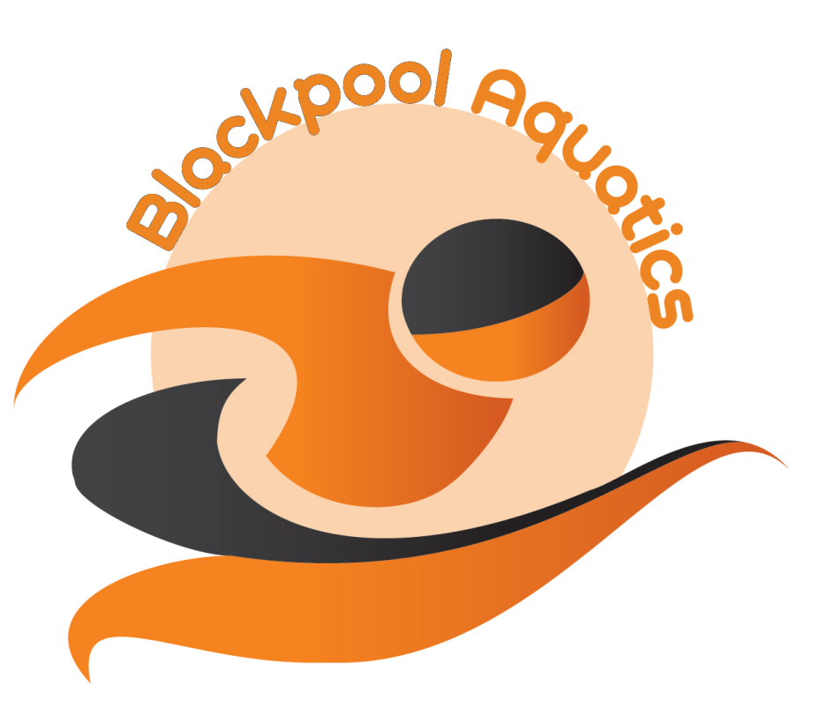BLACKPOOL ROCKS MEET 2016
Licence No. 3NW160510
PROGRAMME OF EVENTS

SESSION 1 FRIDAY 29 APRIL 2016
WARM UP 5:30 P.M. START 6:30 P.M.
Event 101 Girls 400m Freestyle
Event 102 Boys 400m Freestyle

SESSION 2 SATURDAY 30 APRIL 2016 SESSION 4 SUNDAY 1 MAY 2016
WARM UP 8.00 A.M. START 9.30.A.M WARM UP 8.00 A.M. START 9.30 A.M.
Event 201 Girls 200m I.M. Event 401 Boys 200m I.M.
Event 202 Boys 50m Fly Event 402 Girls 50m Fly
Event 203 Girls 50m Back Event 403 Boys 50m Back
Event 204 Boys 200m Back Event 404 Girls 200m Back
Event 205 Girls 100m Breast Event 405 Boys 100m Breast
Event 206 Boys 100m Free Event 406 Girls 100m Free
Event 207 Girls 200m Fly Event 407 Boys 200m Fly

SESSION 3 SATURDAY 30 APRIL 2016 SESSION 5 SUNDAY 1 MAY 2016
WARM UP/START TBC WARM UP/START TBC
Event 301 Boys 100m I.M. Event 501 Girls 100m I.M.
Event 302 Girls 200m Free Event 502 Boys 200m Free
Event 303 Boys 50m Free Event 503 Girls 50m Free
Event 304 Girls 100m Back Event 504 Boys 100m Back
Event 305 Boys 200m Breast Event 505 Girls 200m Breast
Event 306 Girls 50m Breast Event 506 Boys 50m Breast
Event 307 Boys 100m Fly Event 507 Girls 100m Fly

