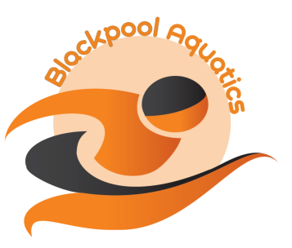
NORTH LANCS S&WPA 9/14 OVER YEARS LEVEL 3 DEVELOPMENT MEET 2016 ENTRY FORM
License No: 3NW161319

FORENAME: | SURNAME:

ADDRESS:

 | POSTCODE:

PHONE:

EMAIL:

MALE/FEMALE  (delete as appropriate) | D.O.B.
A.S.A. REG NUMBER | AGE AT 24 JULY 2016

CLUB:

Please Note:

200I.M. and 100M Freestyle, Backstroke, Breaststroke and Butterfly events 11, 12, 13 and 14/ov years

DISTANCE | STROKE | 25M POOL TIMES
50M | FREESTYLE
100M | FREESTYLE
200M | FREESTYLE
50M | BACKSTROKE
100M | BACKSTROKE
200M | BACKSTROKE
50M | BREASTSTROKE
100M | BREASTSTROKE
200M | BREASTSTROKE
50M | BUTTERFLY
100M | BUTTERFLY
200M | BUTTERFLY
100M | INDIVIDUAL MEDLEY
200M | INDIVIDUAL MEDLEY

Number of Entries: |  | @ £4.00 | Total £

Club Closing Date:

MEET CLOSING DATE: MIDNIGHT MONDAY 27 JUNE 2016

